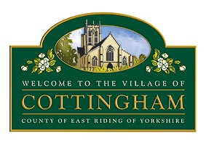

POLICY FOR DEALING WITH THE PRESS/MEDIA

Communications with the Press and Public

Press reports from the Parish Council and Committees etc should be from the Chairman or the Clerk or via the reporter’s own attendance at a meeting.

Press releases will be drafted by the Clerk and only issued after approval by the Chairman. Members and Officers, who wish to issue publicity, excluding electoral material, concerning an activity in which the Council was involved, will be required to consult the Clerk and Chairman before publication.

All official enquiries from the press to the Parish Council should be directed to the Chairman.

Members who are asked for comment by the press or public on matters relating to the business of the Parish Council, should ask that it be clearly reported that it is their personal view and that the views of the Parish Council can be obtained by contacting the Chairman.

Adopted by the Cottingham Parish Council at its Meeting on Thursday 21 February 2013 under minute reference 1809 ‘After discussion it was Proposed by Cllr Hardwick, Seconded by Cllr Casson and, on a show of hands vote, unanimously RESOLVED that the previously circulated Policy for Dealing with the Press/Media (attached to the Minutes as Appendix 2) be adopted.’

